# **Getting started with spring boot**

**Step-1**   **generate project using spring initializer with needed dependency**

**1- Spring Web**

**2- Spring Actuator**

**3- Spring JPA**

**4- Spring Dev tool**

**5- Web Validation**

**6- MySQL Driver**

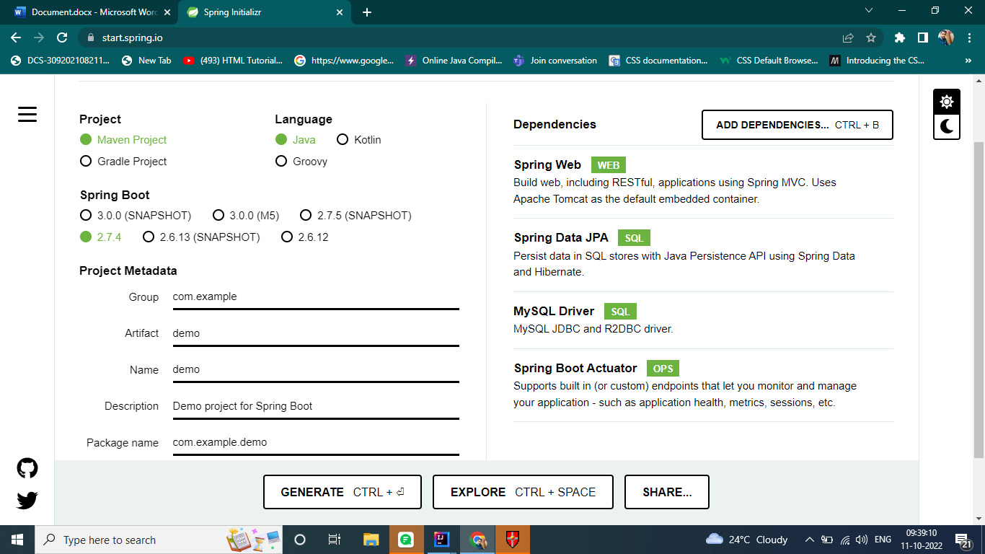

**Step – 2 Import Project on IDE (Intelli J IDEA)**

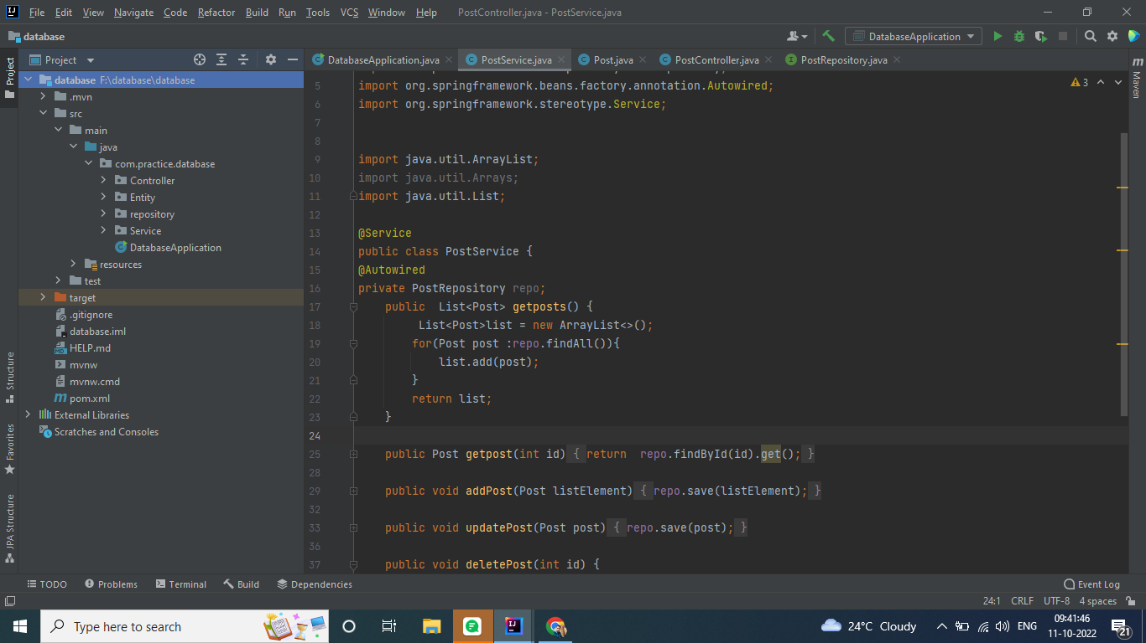

**Step – 3 Make Entity Class IN Entity package**

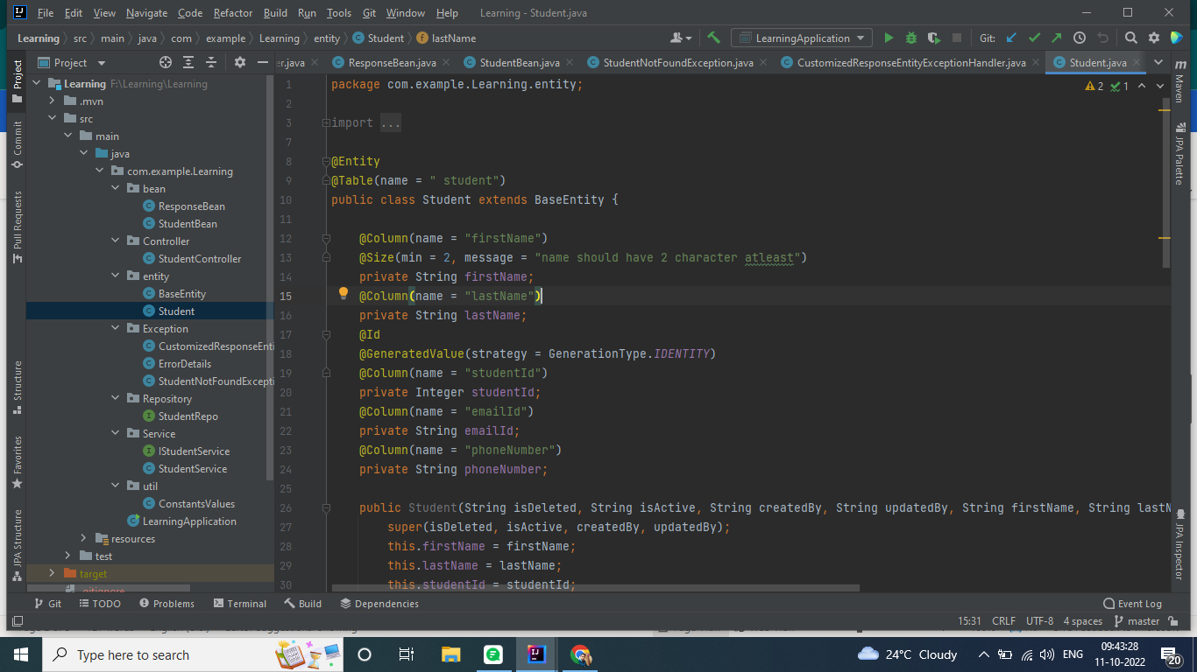

**Step – 4 Make Bean class 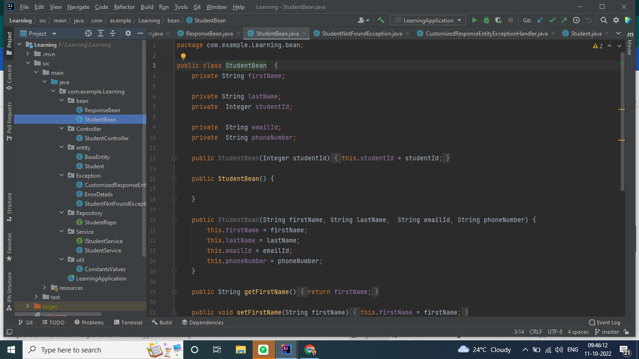IN bean Package**

**Step – 6 EXTEND JPA Repository in your entity repo interface**

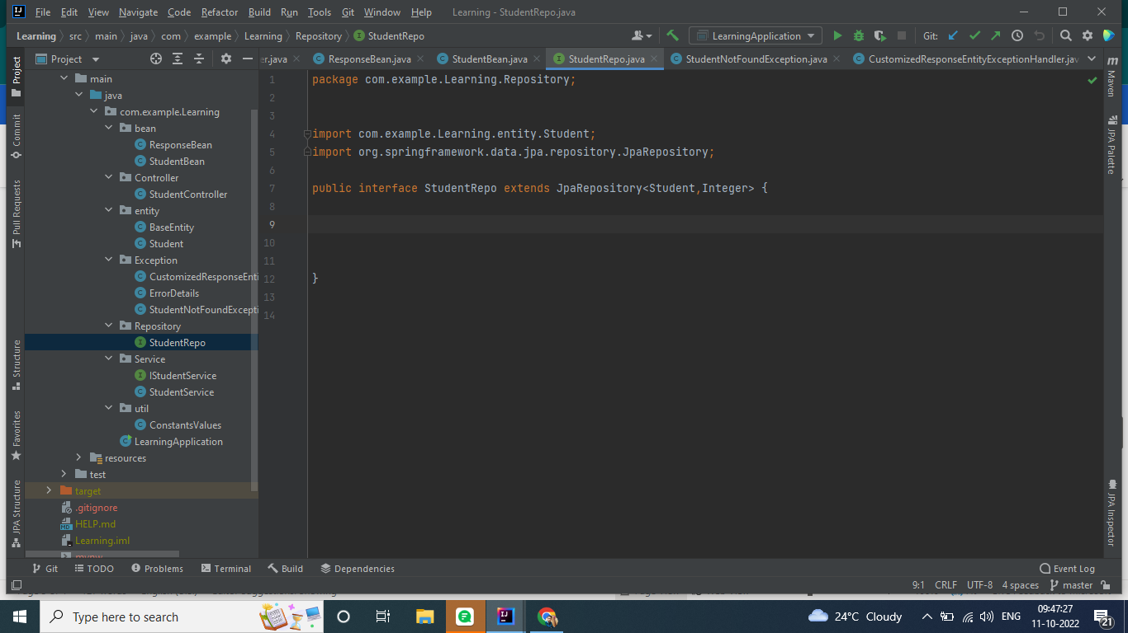

**Step – 7 Make Service Interface**

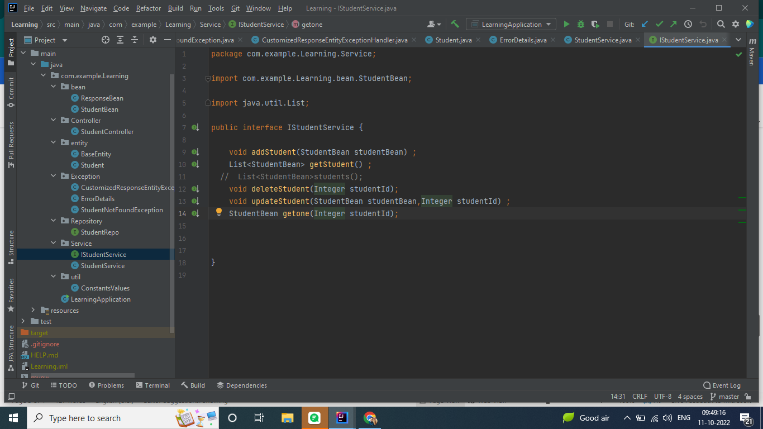

**Step – 8 Implement Service Interface in Service Class in service Package**

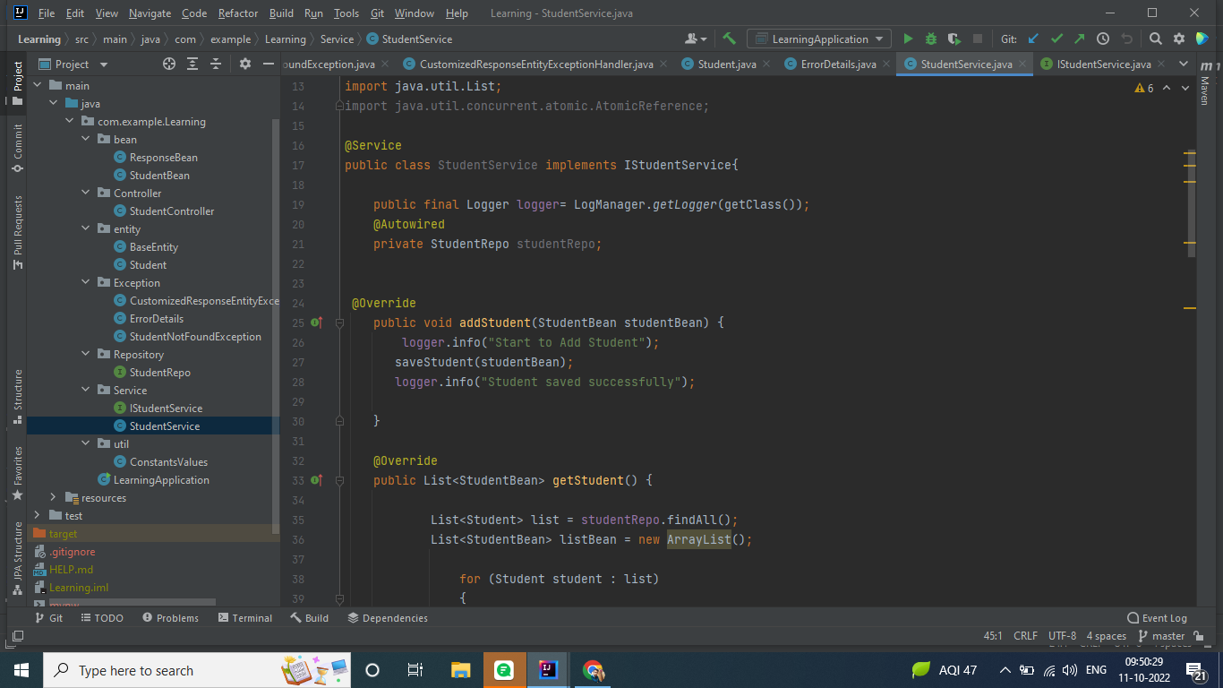

**Step – 9 make Controller Class in controller package**

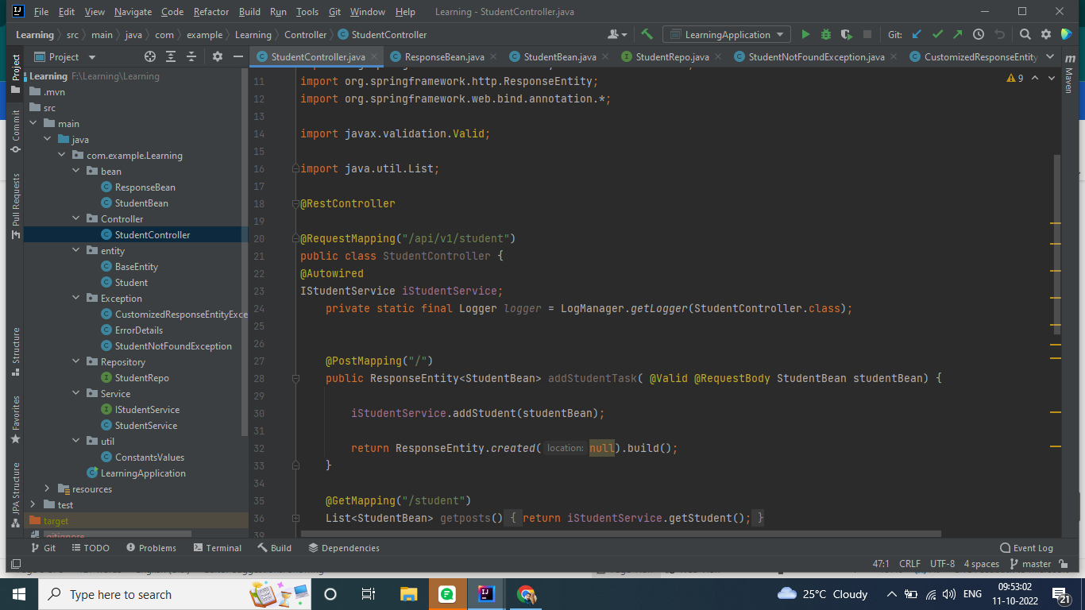

**Step –10 Configure the Database Settings in Application. Property file**

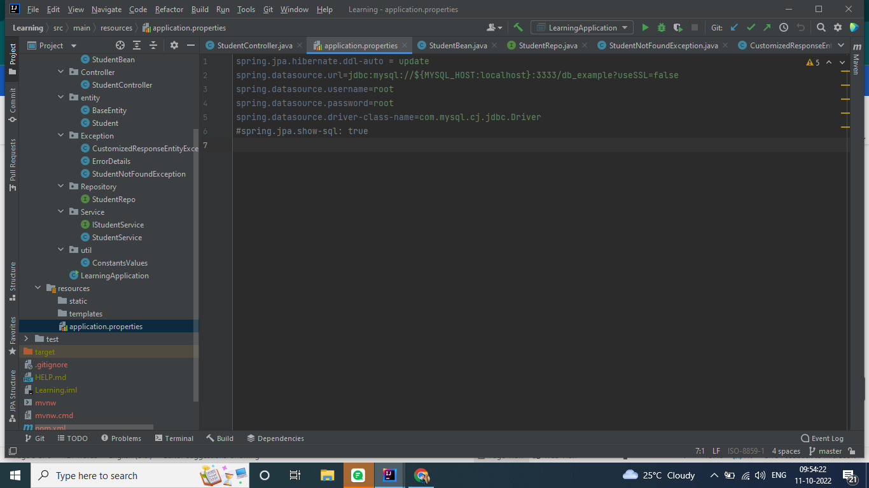

**Step – 11 Handle the Exception in customized Way Through making Error**

**Detail Class and customized Error handling Class**

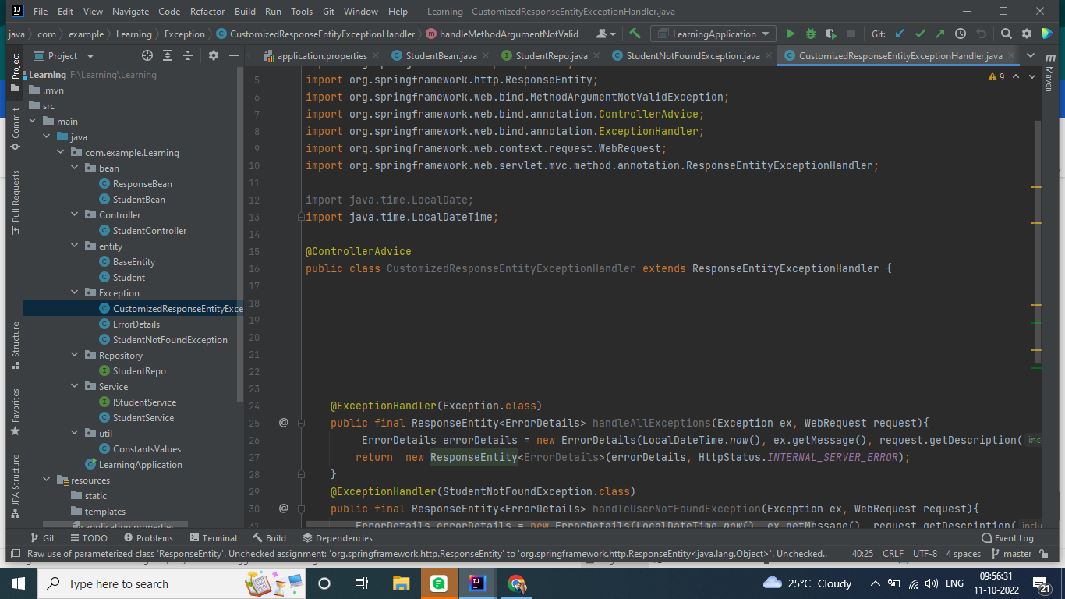

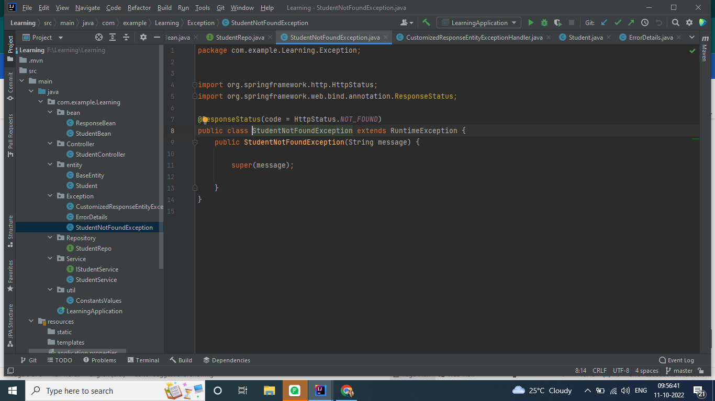

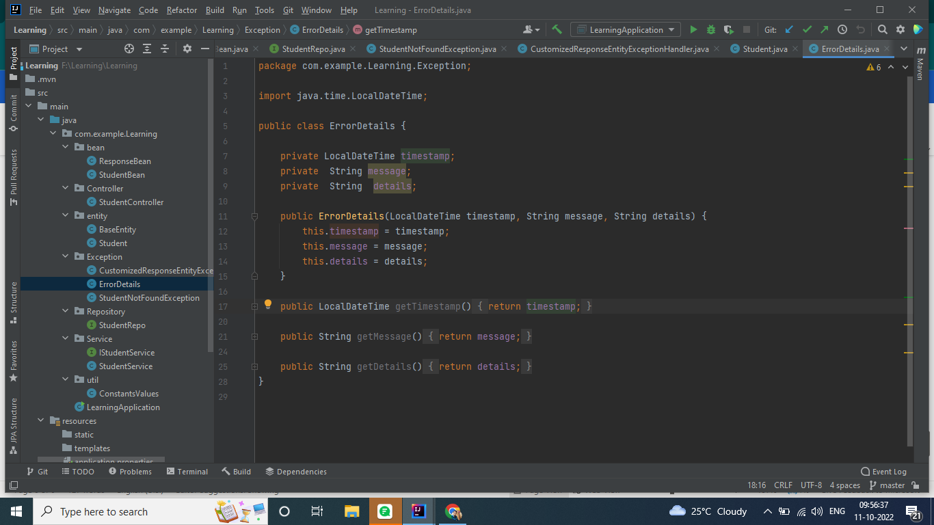

**Step – 12 Add Validation in Entity class.**

